**COVID-19 NON-CONTACT THERMOMETER**

**J Component Project Report for the course**

**CSE2006 Microprocessor and Interfacing**

*by*

**Mausami Mahesh Karogal(19BCE1011)**

**Neha Bheemisetty(19BCE1255)**

**P Subiksha (19BCE1255)**

*Submitted to*

**Dr.D.Vydeki**



SCHOOL OF ELECTRONICS ENGINEERING

VELLORE INSTITUTE OF TECHNOLOGY

CHENNAI - 600127

*June 2021*

***Certificate***

This is to certify that the Project work titled “**COVID-19 NON CONTACT THERMOMETER**” is being submitted by **Mausami Mahesh Karogal(19BCE10****11), Neha Bheemisetty(19BCE1255)** and **P Subiksha (19BCE1255)** for the course **Microprocessor and Interfacing**, is a record of bonafide work done under my guidance. The contents of this project work, in full or in parts, have neither been taken from any other source nor have been submitted to any other Institute or University.

**Dr.D.Vydeki**

**ABSTRACT**

In this tough situation of pandemic, continuous temperature check is mandatory to detect a covid patient. Using the ordinary thermometer involves contact with the mouth or armpits, which leads to the spread of the virus. To prevent that, the effort is to come up with a non-contact thermometer which is also known as a temperature gun. The main objective is to provide reliable temperature monitoring and to prevent spreading of virus to healthy people. The main component used is MLX90614 Non-contact temperature sensor. It has an I2C interface to communicate with microcontroller. This sensor can measure the temperature without the touch of the object. Scale is 0.5 degree Celsius. The output from this sensor will then be connected to Arduino Nano (here used as a microcontroller). Compared to normal thermometers, non-contact thermometers will read the body temperature as early as possible and people can get their accurate temperature. As the cases are increasing abruptly, the demand for non-contact thermometers is rising day to day. And this non-contact thermometer would be really helpful in crowd places like airports, hospitals, offices, colleges, etc., since if we try to measure through normal Thermometer it will be time consuming and it might create chaos. We can get the temperature reading both in Celsius as well as Fahrenheit by using functions.

**Table of Contents**

|  |  |  |  |
| --- | --- | --- | --- |
| **Chapter No.** | **Title** | | **Page No.** |
|  | **Abstract** | | **iii** |
| **1** | **Introduction** | | **5** |
|  | 1.1 | Objectives | **5** |
|  | 1.2 | Scope | **6** |
| **2** | **Design/ Implementation** | | **7** |
|  | 2.1 | Introduction | **7** |
|  | 2.2 | Design Approach | **8** |
|  | 2.3 | Proposed System | **8** |
|  |  | 2.3.1 Economic Feasibility | **8** |
|  |  | 2.3.2 Technical feasibility | **9** |
|  |  | 2.3.3 Operational feasibility | **9** |
|  | 2.4 | Overview of Software | **10** |
|  | 2.5 | Hardware Specification | **11** |
|  | 2.6 | Software Requirement - Code | **11** |
|  | 2.7 | Summary | **11** |
| **3** | **Result and Analysis/Testing** | | **12** |
|  | 3.1 | Flowchart  Code Snippet  Working Procedure  Readings | **12**  **12**  **13**  **14** |
| **4** | **Conclusion and future Enhancement** | | **15** |
| **5** | **Appendix** | | **17** |
| **8** | **References**  **Bio- Data** | | **18**  **18** |

**1 . INTRODUCTION**

**1.1.Purpose**

Due to the pandemic, continuous monitoring of body temperature is  mandatory for a person affected by Covid-19 or having symptoms of the Covid-19. There are many types of thermometers available outside. But only contact thermometers are available in the market. The thermometers which are available can measure the temperature only when there is contact with the person. If the person affected with the Covid-19 has used the thermometer, this may lead to the spread of the virus. In order to prevent the spread of corona virus through a normal thermometer, we can make use of non-contact thermometers. These non-contact thermometers are also called temperature guns. China is the country which is the biggest manufacturer of temperature guns. And these Non-Contact Thermometers are very costly. Also the production of these Non-Contact Thermometers became very difficult. A normal middle class person could not afford to buy.

In this project we will be explaining how to make a Non-Contact Thermometer i.e., a temperature gun with some available components.

Arduino will print the temperature on our smart phone with the help of Serial Monitor Android App. Here there is no need of external power supply because arduino and sensor (measures the temperature) will take power from our smart phone.

**1.2. Scope**

As the number of Covid-19 cases are increasing rapidly, it is very important or mandatory to have a continuous body temperature check. The Covid-19 non-contact thermometer helps us to measure the temperature without contact with the body. It is helpful in accurate and fast measurement of our body temperature, without causing discomfort. There are many symptoms of Covid-19 like dry cough, tiredness, difficulty in breathing, etc. And another important symptom is fever (high body temperature). In an effort to contain any possible risk of infection, this non-contact thermometer is a good way to detect the body temperature. The main advantage of this thermometer is it ensures that there will be no spread of the virus from the infected person to the others. Virus spreads through physical contact, so this Non-Contact Thermometer plays a vital role in not spreading the virus. These non-contact devices can quickly measure and display a temperature reading so a large number of people can be evaluated individually at points of entry. Using non-contact temperature measurement devices may help reduce the risk of spreading COVID-19 infections. Non-contact infrared thermometers require minimal cleaning between uses. Due to these reasons there is a demand on these Non-Contact Thermometers.

**2. DESIGN IMPLEMENTATION**

**2.1 INTRODUCTION**

The main component of this Non-Contact Thermometer is a MLX90614 Non-contact temperature sensor. The output from this sensor is connected to Arduino Nano. Arduino prints the temperature on a smart phone with the help of Serial Monitor Android App. So no need for an external power pack. Because Arduino and sensors will take power from smart phones.

MLX90614 is an IR Temperature sensor for non-contact temperature measurements. It has an I2C Interface to communicate with microcontrollers. Here we use Arduino Nano as a microcontroller. This temperature sensor can measure the temperature without touching the object. It has 0.5 degree Celsius over a wide range of temperatures.

**2.2 DESIGN APPROACH**

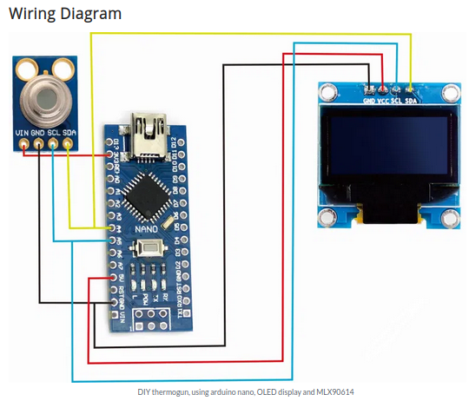

**2.3.PROPOSED SYSTEM**

**2.3.1.Economic Feasibility**

In addition to the market analysis, the financial assessment is a critical component of the feasibility study. Without the “financials” it will be impossible to determine how feasible the business idea is. Included in the financial assessment is revenue and costs to determine how high are the risks of your investment.

The total circuit cost will be approximately around Rs 3000/-. Much of power consumption won’t be there since Arduino takes up power from laptop connected. We can also make portable thermometer using battery of 9V.

**2.3.2.Technical Feasibility**

The components which are used in the project are need to be taken special care. Since damage to any of the components could not give the correct readings. And can result in fatal readings. The components used in the project are easy to handle.

Our project will be technically feasible because the components that we have used are of great efficiency in the easily available in the technical market.

The method that is used to detect the temperature is very simple and will be easy for the users and buyers will be the main stakeholders in this whole system.

The whole module is very simple to understand and is very user-friendly to configure a lay man can easily go through the manual and easily configured this whole setup.

**2.3.3.Operational Feasibility**

This can be operated at home without any complications. The non-contact thermometer helps not spreading the virus, which is more important during this pandemic. The proposed model satisfies with the requirements of the current pandemic situation and helps not spreading any kind of virus/germs/diseases in between the people. The non-contact thermometers are very easy to use. And these thermometers are handy, portable. These can be carried by the people so easily. It also costs so less. The main problem we have chose this project is because of this pandemic. The people need to take care of themselves to survive. The proposed model is worthy in solving the problem of non-spreading of the virus.

**2..4 OVERVIEW OF SOFTWARE**

The software used in Arduino IDE to code arduino and load. We need to detect the address of i2c devices – Oled and MLX90614 sensor using respective libraries. Arduino IDE is one feasible software to code any type of microcontroller and gives the option of Serial Monitor to record the output. The object temperature is measured using read object temperature of mlx library and the room temperature is also measured. Here,initially threshold value is 0 and later it will be added for correct measurement of mlx temperature value. Then the distance of the object firstly,object’s temperature (at center),and then room temperature will be printed on the serial monitor. To display the object’s temperature in celsius use function mlx.readObjectTempC() and to display the object’s temperature in Fahrenheit use function mlx.readObjectTempF()

**2.5 HARDWARE SPECIFICATION**

* MLX90614 ESF Non-Contact Human Body Infrared Temperature Measurement Module
* 0.96inch 12C/IIC 4-Pin OLED Display Module
* Breadboard
* Laptop / Android Device
* Male to Female Jumper wires 40Pcs 10cm
* Mini USB Cable

**2.6 SOFTWARE SPECIFICATION**

* Arduino IDE

**2.7 SUMMARY**

Body temperature can be measured in a number of ways. Traditionally, body temperature has been measured using contact thermometers that are placed on the forehead or in the mouth, ear, armpit or rectum. Non-contact thermometers allow a person’s temperature to be taken with minimal contact with the person. The MLX90614 non-contact temperature sensor is nothing but IR temperature sensor which can measure the temperature of objects held at 1- 20 cm , we will display the output using OLED in Celcius.

**RESULT AND ANALYSIS TESTING**

**FLOWCHART**

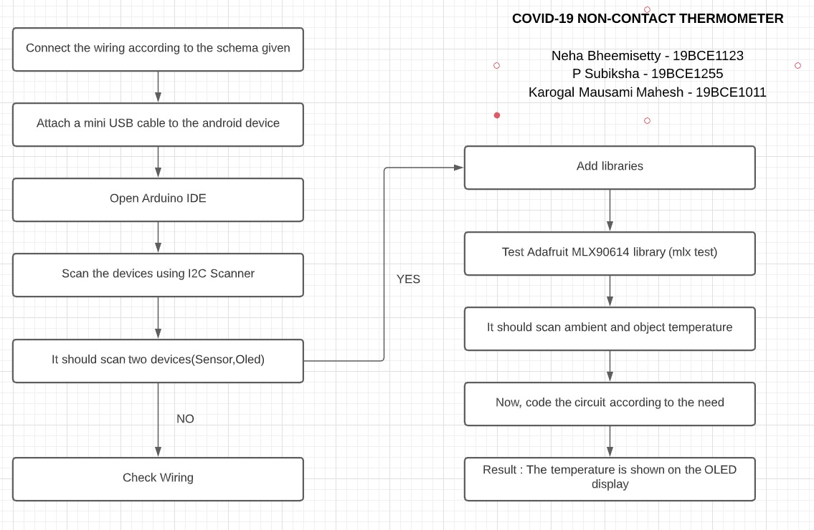

**CODE SNIPPET**

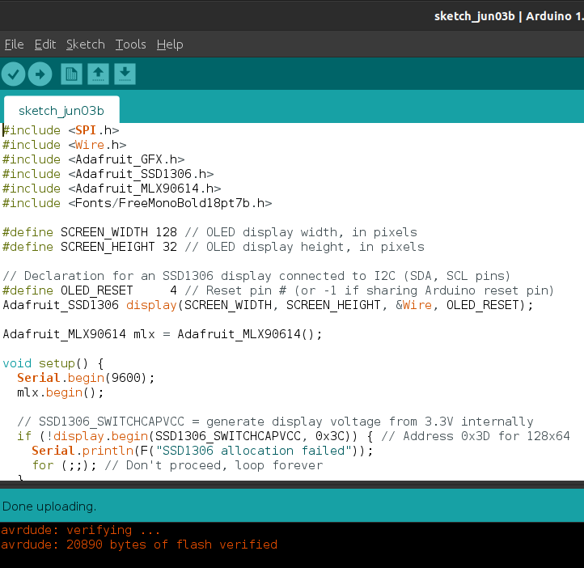

**WORKING PROCEDURE :**

**STEP 1 :**

Connect Arduino Nano to breadboard

**STEP 2 :**

Connect Vcc and GND of OLED and Sensor to 3.3V and GND of Arduino respectively

**STEP 3 :**

**Sensor : Oled :**

SDA → A4 SDA → A4

SCL → A5 SCL → A5

**STEP 4 :**

Connect the Arduino to device which has Arduino IDE installed using USB MINI cable

**READINGS**

**1. Human temperature - The human temperature is recorded in Celsius**

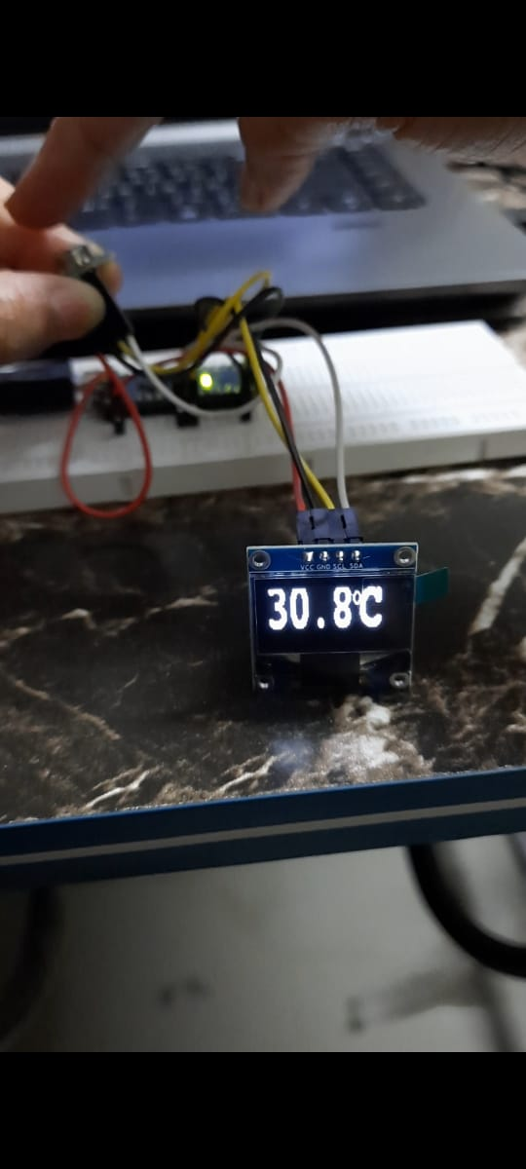

**2. Cold objects – the temperature can even be recorded in -degree Celsius**

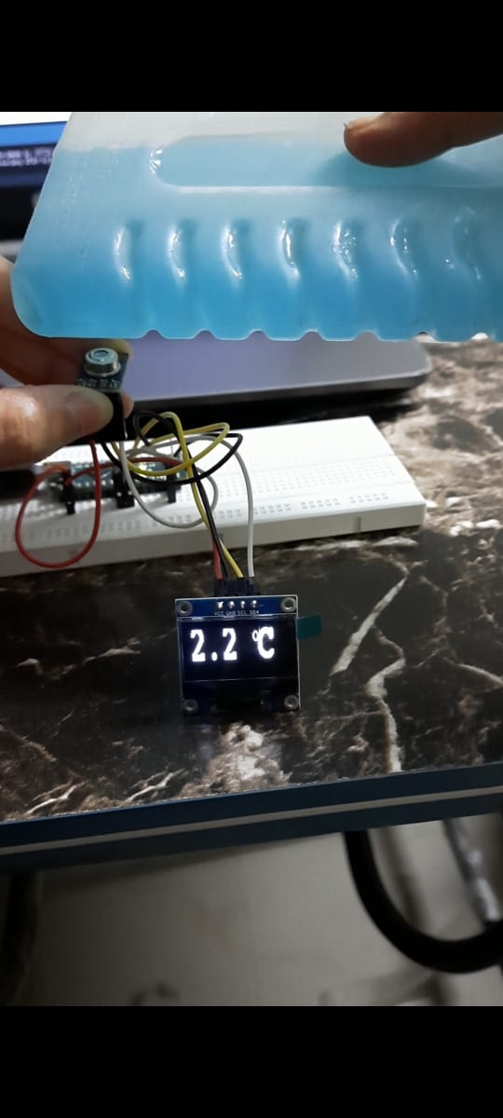

**CONCLUSION AND FUTURE ENHANCEMENT**

Thus, we have designed a non-contact thermometer using Arduino, Oled Display and MLX90614 sensor, which is handy, portable, cost-effective and highly effective as well. Such thermometers are hugely in demand for safety of the people. The non-contact thermometers actually reduce the risk of spreading of the disease between people. These thermometers are very easy to use, clean. Also, the non-contact thermometers measure the temperature and displays a reading which is very quick and accurate. And these non-contact thermometers can be used in different places where the regular checkup of the temperature is needed. It can be used in the airports, hospitals, Banks, etc., Thus, the given system can be proved useful and effective in view of the above features.

**FUTURE SCOPE:**

The future steps can be taken to implement more of the temperature thermometer in regard to storing the previous temperatures and then analyzing if the person records temperature more than average human temperature consistently.

This should be used by us in daily life and this can replace the mercury thermometers as germs /viruses can spread via contact thermometers.

**APPENDIX**

**CODE IMPLEMENTATION:**

#include <SPI.h>

#include <Wire.h>

#include <Adafruit_GFX.h>

#include <Adafruit_SSD1306.h>

#include <Adafruit_MLX90614.h>

#include <Fonts/FreeMonoBold18pt7b.h>

#define SCREEN_WIDTH 128 // OLED display width, in pixels

#define SCREEN_HEIGHT 32 // OLED display height, in pixels

// Declaration for an SSD1306 display connected to I2C (SDA, SCL pins)

#define OLED_RESET 4 // Reset pin # (or -1 if sharing Arduino reset pin)

Adafruit_SSD1306 display(SCREEN_WIDTH, SCREEN_HEIGHT, &Wire, OLED_RESET);

Adafruit_MLX90614 mlx = Adafruit_MLX90614();

void setup() {

Serial.begin(9600);

mlx.begin();

// SSD1306_SWITCHCAPVCC = generate display voltage from 3.3V internally

if (!display.begin(SSD1306_SWITCHCAPVCC, 0x3C)) { // Address 0x3D for 128x64

Serial.println(F("SSD1306 allocation failed"));

for (;;); // Don't proceed, loop forever

}

display.clearDisplay();

}

void loop() {

printText();

delay(500);

display.clearDisplay();

}

void printText() {

display.setFont(&FreeMonoBold18pt7b);

display.setTextColor(WHITE);

//display.print("your temp is");// Draw white text

display.setCursor(0, 20);

display.print(mlx.readObjectTempC(),1);

display.drawCircle(87, 5, 3, WHITE);

display.setCursor(90,20);

display.print("C");

display.display();

}

**REFERENCES**

* <http://infrarougekelvin.com/wp-content/uploads/2016/06/4A-IR-Basics-2.pdf>
* <https://www.electronics-lab.com/project/infrared-thermometer-arduino-mlx90614> [temperature-sensor/](https://www.electronics-lab.com/project/infrared-thermometer-arduino-mlx90614-temperature-sensor/)
* <https://www.researchgate.net/publication/309262087_Design_of_a_non> [contact_infrared_thermometer](https://www.researchgate.net/publication/309262087_Design_of_a_non-contact_infrared_thermometer)
* <https://maker.pro/arduino/projects/build-an-infrared-thermometer-arduino-and-mlx90614>
* [https://robu.in/how-to-design-thermometer-using-arduino](https://robu.in/how-to-design-thermometer-using-arduino/)
* <https://circuitdigest.com/microcontroller-projects/ir-thermometer-using-arduino-and> [temperature-sensor](https://circuitdigest.com/microcontroller-projects/ir-thermometer-using-arduino-and-ir-temperature-sensor)
* <https://circuitdigest.com/microcontroller-projects/contactless-smart-thermometer-using> [mlx90615-ir-temperature-sensor-arduino-and-android](https://circuitdigest.com/microcontroller-projects/contactless-smart-thermometer-using-mlx90615-ir-temperature-sensor-arduino-and-android)

**BIO DATA**

**Name: Mausami Mahesh Karogal**

Contact : 8452068672

Email id : mausamimahesh.karogal2019@vitstudent.ac.in

**Name: Neha Bheemisetty**

Contact : 9014768288

Email id : bheemisetty.neha2019@vitstudent.ac.in

**Name: P Subiksha**

Contact : 7550187364

Email id : subhiksha.p2019@vitstudent.ac.in